

JESSICA ETCHECHURY

April 19, 2019

**INTRODUCTION:**

The following report is a summary of the analysis conducted on data from nine weather stations found in the Honolulu, Hawaii area. The data examined spanned from 2010-01-01 to 2017-08-23. The analysis was completed using SQL Alchemy, ORM queries, Pandas, and Matplotlib.

**DATA OVERVIEW:**

The data set was composed of two tables, Measurement and Stations. The Measurement table was composed of five columns of information: id, station, date, precipitation (prcp), and temperature observations (tobs). The Station table was composed of six columns of information: id, station, station name, latitude, longitude, and elevation.

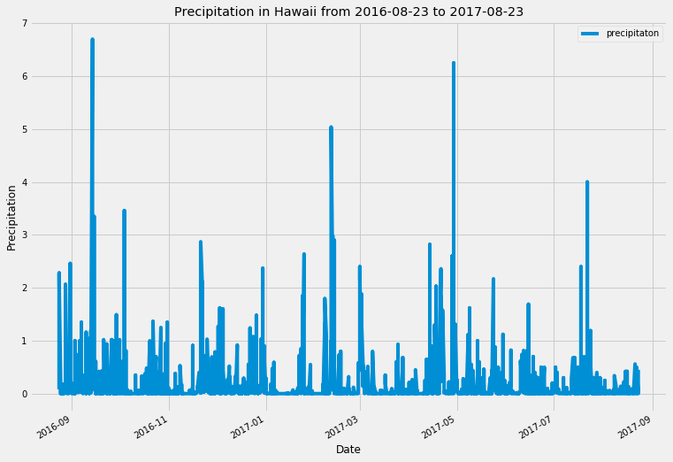

Figure 1

**PRECIPITATION ANALYSIS**

A query was designed to retrieve the last 12 months of precipitation data. The data was then plotted as seen in Figure 1. From the precipitation data it seems that there is a spike in precipitation annually.

**STATION ACTIVITY**

A query to analyze the activity level of each station was conducted. In order to complete this query both the Measurement and Station tables were used by doing a join using the station column. It was found that the station in Waihee had the most weather data with 2,772 recorded entries. That station with the least amount of data was Upper Wahiawa with 511 entries.

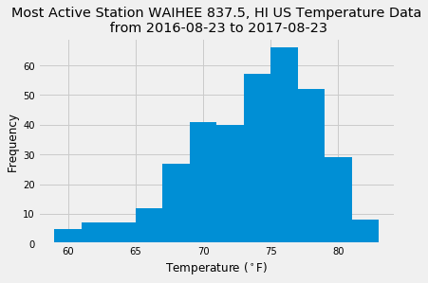 The temperature data for the most active station, Waihee, was examined more closely. A query was completed to determine the high, low, and average temperature at Waihee. The query found the high temperature to be 85°F, the low to be 54°F, and the average to be 71°F. The frequency of temperatures was also examined and can be seen in Figure 2. It shows the frequency of temperatures for the Waihee station for the span of year.

Figure 2

**TRIP ANALYSIS**

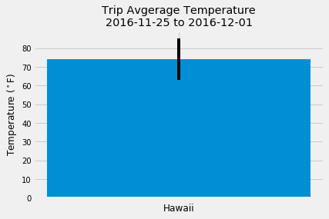 As part of the analysis, the data for a fictitious trip was extracted using queries and analyzed. The dates for this particular trip was 2016-11-25 to 2016-12-01. Figure 3 shows the average temperature, 74°F, with a bar. The minimum (67°F) and maximum (78°F) temperatures are marked using the y error bar.

Figure 3

In addition to temperature data, precipitation data was also examined for the same time frame. As shown in Figure 4, the query for the precipitation data for this time frame only returns data from seven of the nine stations.

Figure 4

Finally, the daily normals for the trip were calculated by finding the minimum, average, and maxiumum temperatures for each day of the trip. After finding the norms for the range of dates, the data was plotted on an area plot as seen in Figure 5. The temperature appears to be consistent during this time period.



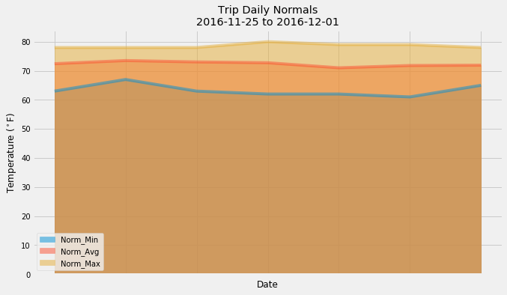

Figure 5

**RECOMMENDATIONS/CONCLUSIONS:**

* The data sets used were incomplete. There are some null values in the Measurement table. These null values could potentially result is skewed data and incorrect analysis.
* Upon examining the precipitation data for the fictitious trip, it was discovered that not all nine stations recorded data throughout the history of the data set. As seen in Figure 5, there are only seven stations listed in the table. When the same query is completed on the entire span (2010-01-01 to 2017-08-23) of the data set all nine stations are accounted for as seen in Figure 6. This could be due to the fact that some of the weather stations may have closed between 2010 and 2016, or may not have been collecting data during that time period.



Figure 6